Project report

Overview: The name of project is Hospital management system. This project is made by structure programming language (C). This is consoling base application. I made this project in CodeBlocks.In this project we used data structure, link list (single and double) array to store data and retrieve data from file. Moreover, some searching algorithm method implemented in this project.

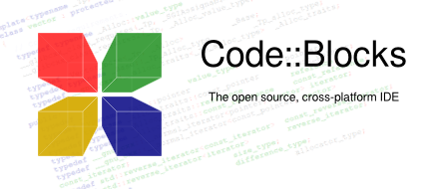

Feature of project:

1. Record patient data.
2. Search Patient by room, by doctor, by unite.
3. Delete record.
4. Become blood donor.
5. Search Emergency blood donor
6. Doctor list

Outcome of project

By this we can easy monitor any hospital like in case of record, search, delete patients. Maintain the doctor service. And most valuable thing is we can provide those patient who needs immediate need blood as like as blood bank.